Embedded System Design & Consulting Services

ELREG is an embedded software and hardware development and prototyping company based in Sarejevo, Bosnia.
Elreg consists of a team of software and hardware engineers, as well as a small production department. The company specialises in quick and correct design from a customers loose specification, to a fully approved, mass producible product.
The full or partial design and implementation process can typically involve the following stages:
Loose concept design to specification: Using a series of meetings with allocated engineers, the customers ideas or function specification, is worked into a full specification, with time flows and approximate costs. Once the main modules involved are specified, tasks are place in Atlassian Jira tools, a web environment allowing the customer to follow the detailed progress, and adjust where necessary.
Prototype implementation. Depending on the project timeframe, a prototype is made, using an agreed CPU module. Either using manufacturer prototype boards or with a designed backboard. Designs are modular, with years of experience being used to make a correct solution, quickly and using good design practices to reduce EMC approval times.
OS/driver implementation. The team of embedded software engineers build or adjust the operating system (if required) to the specific needs.
Application implementation: The Software engineers design a concept software, where possible making the GUI portable to a windows environment for customer verification.
Production Protoype: After proving the concept, a production prototype is designed in the required format and with the required connectivity. The Drivers are designed to port into this prototype, and software continues to be designed by Elreg, or the customer themselves.
Approval: Elreg has some experience of approving their solutions with the stringent maritime MED approval programs, products have typically only required minor adjustments to pass such tests.
Follow up: After approval the required changes are made quickly and if required a rework can be performed to reduce the production costs. Elreg can also provide follow up on software, drivers and hardware changes as the product ages.

Over the past four years our company has been providing complete embedded solutions as well as support in software and hardware development of embedded systems for our clients.
The majority of our projects have been done for Norway based companies, related to marine industry. This is done primarily using web conferencing tools (skype) and JIRA. Although Elreg has a limited presence in Norway and can attend meetings throughout a project.

Experience

- PCB Layout and Design Support
We offer services of Embedded systems design and development based on ARM9, Cortex M5, M7 processors, electrical schematic and PCB layout design and system documentation creation. We provide wide variety of technical support ranging from in-house project design and development, to modification and improvements of existing projects.
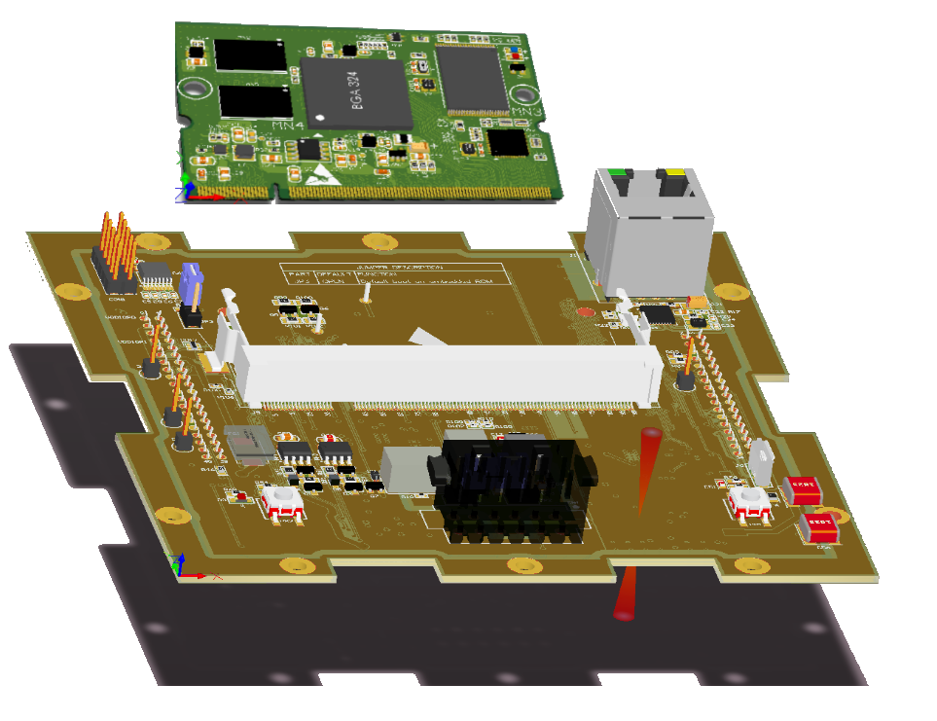

- Excellent knowledge of Altium Designer,
- Best practices for signal integrity and EMI prevention,
- Layout for switching power supplies, low-noise circuits, DDR2/3, LPDDR, LVDS, parallel RGB, resistive/capacitive touch, USB, HDMI, GMII, RGMII, RS422, RS485, CAN …
- Communication with equipment manufacturer, assistance in manufacturing process, procurement of equipment and components.
- System testing, quality assurance and optimization.

- Embedded Firmware
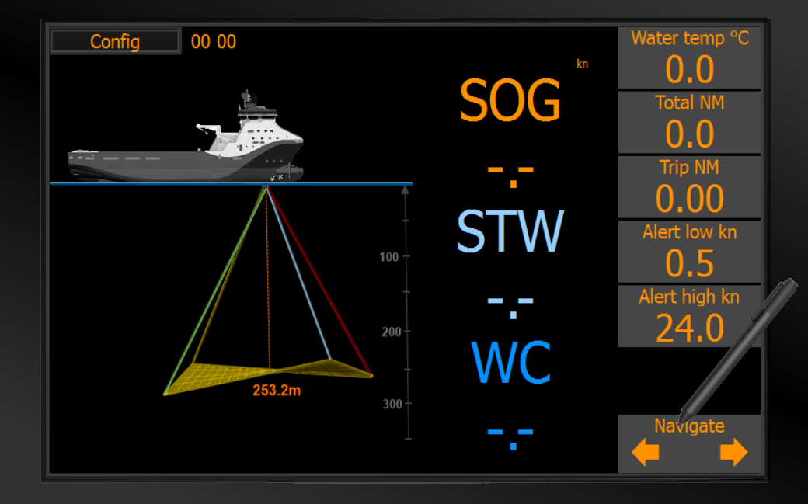
Embedded software, Building Linux Kernel and Root File System
- Various OS’s, such as Linux, FreeRTOS, bare metal …
- Excellent knowledge of C, C++, Qt4/5, C# …
- ARM, Cortex, 8-bits MCU …
- Time-critical algorithms
- Device drivers
- Modular and
- algorithms and device drivers
- Solving the "hard math" problems
- GIT, JIRA, Microsoft project

Cooperation
We prefer long term cooperation with our clients, based on high quality products and mutual trust. Allowing the project owner full overview of project development stages, we tend to offer full insight in time and resources usage. Therefore, project owner is allowed to direct the project development in desired direction. Project tracking is done via Atlassian’s Jira:

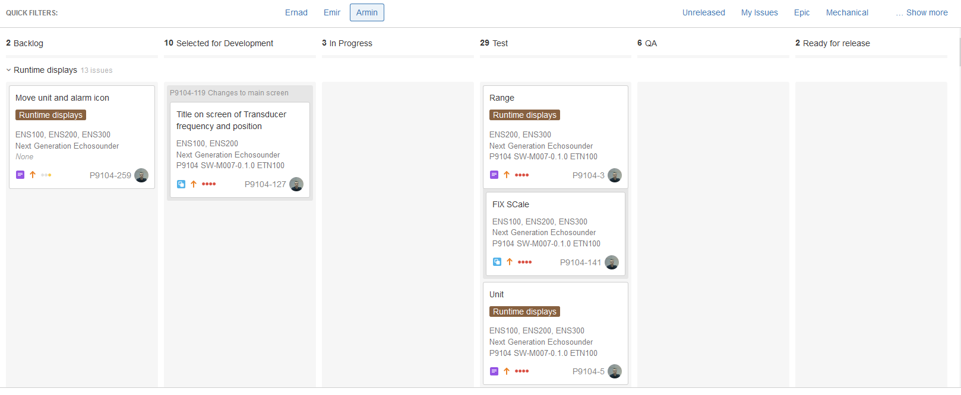
while GIT is used as version control system:
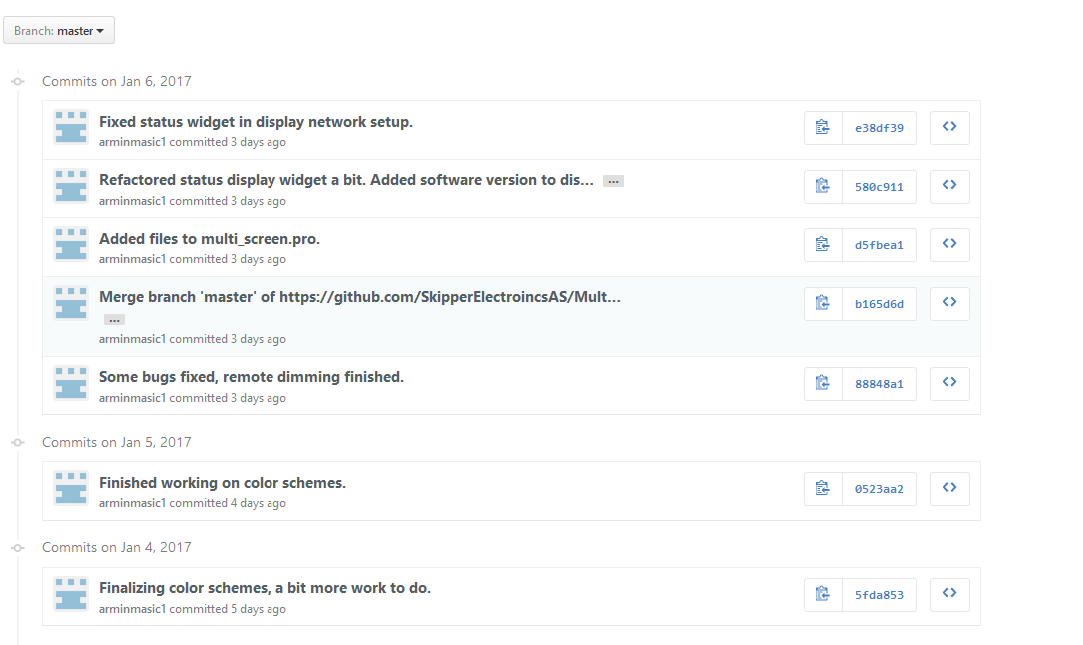
Pricing
Bosnia is a low cost country, but fully European. Elreg has a core staff of fully qualified engineers and computer programmers, and has built up a reputation in Sarajevo district as a dynamic, exciting company with real life projects. As such we have little problem in expanding to meet customer requirements both short and long term. However the core staff covering all the required disciplines provide experience and also use a network of experienced engineers both in Bosnia and Norway to give the ultimate solutions.
Elreg can provide dedicated engineers or time with the relevant engineers.
The pricing is very competitive , and unmatchable in Norway.

Comment from Paul Connelly Technical Director of SKIPPER Electronics AS.
‘Elreg has become a integrated part of our development team, providing extra manpower at half the cost, using them is no different to having our own engineer working from home. As our needs have changed we have added extra capacity, but kept full control of our projects, time line and IP.’

References
Skipper Electronics AS (Norway)
Elreg AS (Norway)
InApril (Norway)

Contact
Should you have any queries or require any further information, please do not hesitate to contact us. We will arrange an introduction meeting on your premises.
Email ???
Elreg d.o.o.
Address:
Tvornicka 3
78000 Sarajevo
Bosnia and Herzegovina
Phone: +387 33 942-121

